Article
AUMOR: Augmented-Reality Based Mobile Application for University Orientation
Muhammad Nadeem ^{1,}*, Melinda Oroszlanyova ¹, Pauly Awad ¹, Hasan Ozkan ², and Svetlana Beryozkina¹
Academic Editor: Firstname Lastname
Received: date
Revised: date
Accepted: date
Published: date
Citation: To be added by editorial staff during production.
Copyright: © 2025 by the authors. Submitted for possible open access publication under the terms and conditions of the Creative Commons Attribution (CC BY) license (https://creativecommons.org/licenses/by/4.0/).
¹ College of Engineering and Technology, American University of the Middle East, Egaila 54200, Kuwait
² College of Business Administration, American University of the Middle East, Egaila 54200, Kuwait

¹ *Correspondence: Muhammad.nadeem@aum.edu.kw
Abstract: Fresh engineering students are often required to absorb a large amount of new information within a short period of time, which can be both academically and emotionally challenging. In response to this challenge, this study introduces AUMOR, a mobile application designed to enhance university orientation by delivering contextual information at the point of need. The application integrates GPS-based localization with QR code triggers to provide real-time, location-specific guidance and interactive content through an augmented reality (AR) interface. It uses GPS functionality to provide real-time location-based services including information about academic buildings, student services, and recreational facilities. The QR code placed on devices and lab equipment provides relevant information upon scanning. The efficacy of the application was evaluated through a user study using paper-based questionnaire involving 128 participants which included both the students and faculty members. The results demonstrate that AUMOR improves users’ spatial awareness during orientation by providing them with important information when needed. This improves navigation confidence, and efficiency in locating campus facilities, while demonstrating high levels of usability and acceptance. The findings suggest that AR-based, context-aware mobile applications such as AUMOR can provide a scalable solution for smart campus environments and contributes to the broader field of context-aware mobile learning and AR-assisted navigation.
Keywords: Augmented Reality (AR), Mobile application, University orientation, GPS Navigation, QR Codes, Technology acceptance model (TAM), Context appropriate information

- Introduction
Every year, many students leave college and enter universities to become successful professionals. As institutions of higher learning, universities are crucial for helping students develop their intellectual capacity and prepare for workforce demands [1], [2]. Fresh students often face problems in navigating campus and obtaining information about related buildings and departments. They also face problems in labs due to a difficult transition from theoretical coursework to practical work. They have to learn about safety protocols and equipment crucial for smooth workflow. Before being permitted to work in the lab, students at many universities must also undergo the laboratory orientation program. Furthermore, campus life often feels like a survival challenge as students race between buildings, get lost indoors, and juggle multiple apps that do not show what is inside a building or how to reach services on time. The result is not just tardiness; it is a steady drain on energy, productivity, mental clarity and confidence [3]. This is less a time-management issue than a design problem, revealing the need for a smarter, student-centric tool to assist teachers in their work [4].
University orientation programs serve as critical transitional experiences for new students entering higher-education institutions. Students who participate in these programs often performed better academically than those who did not attend the orientation program. Due to reasons the orientation of campus including labs is a crucial part of new student onboarding and improves their chances of success. Orientation not only motivates students but also helps them build solid social networks and adjust to the academic environment more effectively [5]. But traditional orientation methods may not always adequately address the diverse needs and preferences of modern learners and may be expensive. For example, orientation fees in the U.S. range from $100 to over $500 per student, with UNC-Chapel Hill charging $232, Stanford $525, and Canadian universities $63 average. Australia uses the Student Services Fee for free "O-Week" events [6] whereas European orientations are typically free. But university orientation programs often face challenges in effectively assisting new students in navigating campus facilities, accessing relevant information, and fostering a sense of belonging among them. Traditional methods may not fully accommodate to the needs and preferences of modern learners, leading to inefficiencies and gaps in the orientation process.
In recent years, advancements in mobile technology have opened new avenues for enhancing the orientation process of new intake of students [7]. Mobile applications have emerged as powerful pedagogical tools for university students. The integration of AR technology with GPS and QR codes into mobile applications offers immersive and interactive experiences by blending digital contents with the physical world [8]. By superimposing virtual information in real-life environments, AR applications can provide students with contextualized guidance, information, and engagement opportunities during university orientation. In 2024, the global augmented reality market was valued at $83.65 billion. From 2025 to 2030, a compound annual growth rate of 37.91% is anticipated [9].
AR technologies are being considered more and more in higher education for their ability to improve spatial understanding, to increase engagement and to make user interaction more natural. For new students, finding their way around a big campus and locating different facilities is still a difficult task. To solve this problem, the research team designed and developed an AR, based mobile orientation app for a real university campus. The evaluation of the system was carried out using a post, deployment user study. The results of the study are useful for adoption of AR, based orientation systems in the real-world educational settings.

- Design and deployment of an AR-based mobile application to facilitate university orientation by providing information about the buildings as well as lab equipment.
- Conducting usability testing and user feedback sessions to assess the ease of use, functionality, and user experience of AUMOR.
- Measuring the effectiveness of the application in supporting students' orientation experience, including their ability to navigate campuses and access to information.
The students can easily access information anytime and anywhere using the app installed on their smartphones or tablets, facilitating a smoother transition into otherwise challenging university life by creating immersive and interactive experiences that engage them in the campus environment. This investigation also gives valued insights and practical solutions for enhancing university orientation practices and transition to university life through the development and assessment of an AR mobile application.

- Literature Review
Universities often conduct orientation programs before the start of the academic term that are designed to provide incoming students with essential information, university policies, procedures, and academic requirements and may include presentations, campus tours, information sessions, and campus events and activities. Many universities also offer online orientation resources to supplement in-person orientation sessions [10], [11] permitting learners to access information according to individual pace and schedules.

  - Role of Mobile Applications in Education
Mobile applications have drastically changed educational methods as well as the ways of students’ access, engagement with educational content. The pervasive use of smartphones has learning experiences that go beyond the limitations of traditional classrooms through flexibility, interactivity, and personalization [2]. There has been a substantial increase in mobile learning research between 2018 and 2022 [12]. The popularity stems from the accessibility offered by mobile devices, enabling students to connect with educational matters at any time and location [13] enhancing student engagement and motivation [14]. Moreover, the availability of interactive and personalized multimedia features caters to the diverse learning styles [15]. The learning pathways can be adjusted dynamically for individual student progress and performance, supporting innovative instructional methods, such as microlearning [16] improving the academic performance of students when compared to traditional methods [17]. The mobile apps have significantly streamlined administrative and support functions in educational institutions [17], [18]. The analysis of huge amounts of digital data provided by the app makes it possible to monitor the student engagement and develop adaptive instructional strategies [13]. To cut short, mobile applications have become integral part of the current educational ecosystems, substantially improving educational outcomes.

  - GPS and QR Code Technologies in Navigation Apps
The integration of Global Positioning System (GPS) and Quick Response (QR) code technologies in mobile apps has significantly enhanced their functionality, accessibility, and usability [19], [20]. All GPS portable devices calculate GPS coordinates of the current location from the data received from the satellite which can be enriched with contextual information, such as time spent and activities at a particular location, to provide more meaningful insights [21]. The accuracy and reliability of GPS are very important in navigation apps, particularly in urban environments with high-rise buildings and signal interference, resulting in signal loss in dense urban areas or indoor environments. This has stimulated the researchers to explore alternative positioning methods and hybrid solutions to improve navigation accuracy. QR code, on the other hand, can streamline the delivery process by providing quick access to essential information and are widely used in industry [22] for managing equipment repairs and maintenance. AR technology allows integration of GPS and QR codes into navigation applications by overlaying digital information, such as route directions, points of interest, and location-based alerts, onto a user's real-world environment in real time, enhancing situational awareness and navigation experience.

  - Previous Studies on Mobile Apps for University Orientation
Early AR-based campus orientation systems primarily focused on visual overlays that annotate buildings, landmarks, and facilities when viewed through a smartphone camera or head-mounted display. Several studies have demonstrated that GPS-based campus orientation applications significantly improve users’ spatial awareness and reduce the time required to locate destinations, particularly in large or multi-campus universities [23], [24]. By integrating digital maps with GPS positioning, these applications allow users to receive turn-by-turn directions and contextual information about nearby facilities. The Columbia University and Fu-Jen Catholic University was one of the pioneers in utilizing AR, specifically to help new students become familiar with the campus layout [25]. [26]. Some researchers gamified such apps to enhance student engagement through immersive and interactive experience through location services and dynamic maps for guiding new students [27], [28]. Researchers have also reported positive user perceptions regarding usability and convenience, especially when GPS navigation is combined with familiar mobile interfaces and interactive map features. Several studies have demonstrated that GPS-based campus orientation applications significantly improve users’ spatial awareness and reduce the time required to locate destinations, particularly in large or multi-campus universities [29], [30]. By integrating digital maps with GPS positioning, these applications allow users to receive turn-by-turn directions and contextual information about nearby facilities [31]. Researchers have also reported positive user perceptions regarding usability and convenience, especially when GPS navigation is combined with familiar mobile interfaces and interactive map features. Some researchers has combined other multimedia features to enhance the navigation systems such as audio and visual elements [32], and voice-command search for locating and sharing places [33], 3D directional board [34]. Others used images of the locations taken through a camera to spot locations or used the campus's Wi-Fi network to find users' positions and provide them with information required at the point of need, as and when needed [35], [23], [36]. Despite these advantages, the literature technical limitations of GPS-based orientation systems in university settings have also been reported [29]. The most prominent challenge is reduced accuracy or complete signal loss in indoor environments. Also, GPS effectively determines user location, but it does not provide insights into building functions, room-level details, or activity-specific guidance [31].
QR (Quick Response) code technology has emerged as a practical and low-cost solution for delivering location-specific information in educational environments, including university campuses. QR codes are two-dimensional barcodes that can be scanned using standard smartphone cameras to instantly access digital content such as maps, textual descriptions, multimedia resources, and web services. Due to their simplicity, scalability, and minimal infrastructure requirements, QR codes have been widely adopted in campus orientation systems, particularly as an alternative or complement to GPS-based navigation in indoor environments where satellite signals are unreliable or unavailable. The researchers have used QR codes to supply context appropriate support and information at the point of need [37], access library resources [38], can effectively support first-time campus users by reducing dependence on printed maps and physical signage, while allowing institutions to update information dynamically without additional cost [39]. The QR codes and videos have also been integrated in mobile orientation games to augment the physical environment of an academic building and learn about people and locations of their program [40]. Despite these benefits, QR-based orientation systems suffer from limitations such as explicit user interaction, dependance on the proper placement, security, and trust issues. The malicious QR code replacement or redirection can expose users to phishing or harmful content if appropriate validation mechanisms are not in place [9].
Previous studies on campus orientation systems demonstrate the potential of mobile, QR-based, and AR-assisted solutions. While GPS-based systems support outdoor navigation, they fail indoors, whereas QR-based systems provide reliable indoor access but lack spatial guidance. AR-based approaches improve engagement but often lack hybrid localization or empirical evaluation. The existing approaches focus either on outdoor navigation using GPS or on indoor information access through isolated mechanisms such as QR codes or Wi-Fi positioning. Many systems rely on additional infrastructure, lack seamless indoor–outdoor integration, or are evaluated only through descriptive or small-scale usability demonstrations. Moreover, few studies employ established technology acceptance frameworks to empirically assess user perception and adoption. To address these gaps, AUMOR proposes a hybrid GPS–QR–AR mobile application that supports both outdoor navigation and indoor context-aware interaction without requiring additional infrastructure. Unlike prior work as shown in Table 1, AUMOR is evaluated through a large-scale user study (n = 128) using a questionnaire, providing empirical evidence of usability, acceptance, and perceived spatial awareness improvement in a real campus environment. The integration of these technologies into AUMOR benefits by combining real-time location tracking with on-demand information retrieval to provide users with seamless navigation experience. The hot loading feature of this does not require any compilation and content can be updated at any time making this app useful for the students throughout their stay at the University due to its ability to deliver information at the point of need.

Table 1. Cited Studies vs. AUMOR
Study | Primary Technology | Indoor Support | Outdoor Support | Interaction Mode | Evaluation Method | Key Limitation | How AUMOR Differs
[23] | AR + GPS | No | Yes | Landmark-based AR | Usability demo | Outdoor-only navigation | Explicit indoor support via QR codes
[25] | AR + GPS | Limited | Yes | AR overlays | Descriptive / demo | Specialized hardware, no large-scale evaluation | Smartphone-based, scalable, empirically evaluated
[26] | AR | Limited | Partial | Visual AR cues | Case-based | No indoor triggering, limited interaction | Hybrid GPS + QR for indoor/outdoor use
[28] | AR | Limited | Limited | Informational AR | Descriptive | No navigation focus | Location-aware navigation + info
[31] | AR | No | Partial | Event-based AR | Qualitative feedback | Narrow use case (events) | Unified orientation + labs + services
[36] | Wi-Fi positioning | Yes | No | Context delivery | System demo | Requires infrastructure | No extra infrastructure
[39] | QR | Yes | No | Scan-to-info | Descriptive | No navigation or AR | AR-enhanced, integrated navigation
AUMOR | GPS + QR + AR | Yes | Yes | Context-aware AR | User study (n=128) | — | Hybrid, scalable, empirically validated

  - Theoretical Framework
This application integrates GPS, QR codes, and AR technologies to provide users with a seamless and enriched experience. GPS provides location-aware information during the navigation and QR codes serve as digital markers and can quickly retrieve specific multimedia contents upon scanning. AR technology overlays virtual information onto physical spaces delivering personalized, context-aware experiences that cater to the diverse needs and preferences of users during university orientation and thereafter.
Figure 1 shows four key theoretical perspectives of AUMOR that inform its design, development, and implementation are: 1) Situated learning theory, 2) information processing theory, 3) UX design principles, and 4) spatial cognition and navigation theory. Each theory contributes to the app's design, functionality, and user interaction. First, the Situated Learning Theory emphasizes the importance of context and social interactions in the learning process [41]. Within the context of GPS and QR code-based AR applications, embedding educational content, interactive challenges, and guided exploration into the user’s surroundings, the application facilitates experiential learning and knowledge acquisition that are directly relevant to the user’s context [42]. The design of AUMOR is also supported by information processing theory which focuses on how learners acquire, process, and retain information [43]. By optimizing the presentation of information, providing scaffolding and guidance, and incorporating interactive elements, it can enhance users’ information-processing capabilities and facilitate effective learning and decision-making [44]. Drawing on principles such as simplicity, consistency, feedback, and affordance [45], UX design informs the development of application interfaces, navigation flow, and interaction design. By prioritizing user needs, minimizing cognitive load, and maximizing usability, it enhances user satisfaction and engagement with the AR experience [46]. Finally, Spatial cognition and navigation theory explores how individuals perceive, interpret, and navigate spatial environments [47]. AUMOR incorporates spatially aware features, such as GPS-based navigation, AR overlays, and landmark recognition, which enhances navigation efficiency and spatial understanding within the physical environment.
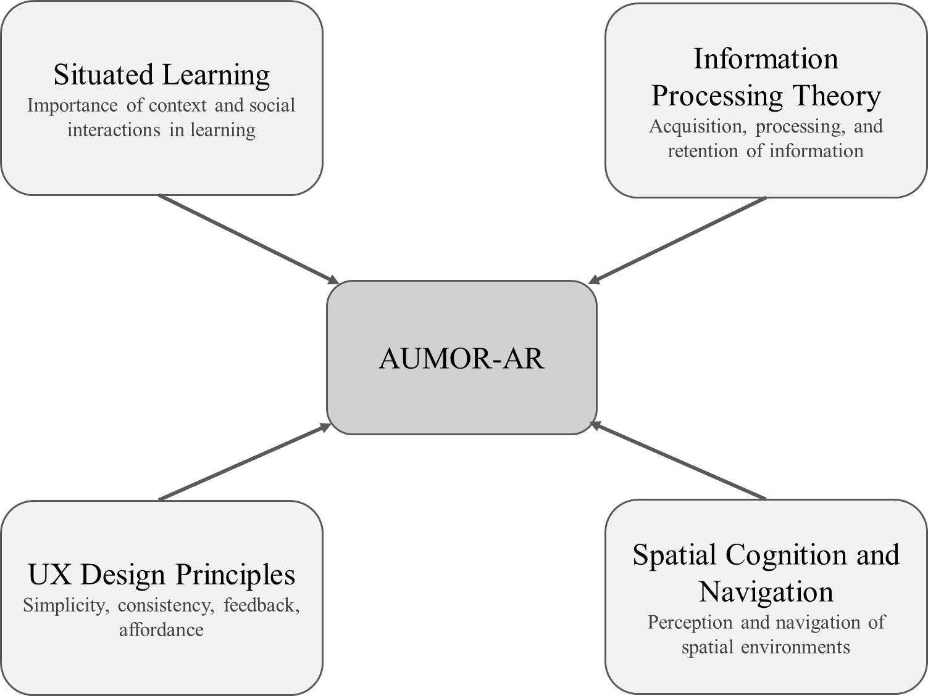
Figure 1. Theoretical Foundations of AUMOR Application.
- System Design and Implementation
AUMOR consists of a remote data server and a wirelessly linked mobile client application that runs on the platform communicating with each other using the JSON protocol. The user engages with the application by using the camera and GPS built into the device to scan the QR code and provide the user's position, respectively. Both the camera and GPS feed their data into the AR Display, which becomes the user's interaction layer with the application. The user request, which includes GPS coordinates or scanned QR information, is structured in JSON format and sent to the remote server. The AR content is stored on a server or repository such as GitHub in JSON-format. The server parses the incoming request, matches the data with the appropriate AR content, and sends a real-time JSON-formatted response containing AR assets such as text, images, or videos. AUMOR parses this response and displays these contents on the mobile display. One of the important features of this app is hot reloading which allows to update the AR dynamically on the server without the need of recompilation saving time, resources, and simplifying content maintenance.
We used an incremental development model for mobile application development because of lower risk due to early testing, early basic working prototype, and flexibility to changing requirements. This iterative approach breaks down a project into smaller and manageable increments or iterations. Each iteration focuses on delivering a specific set of features or functionalities, allowing continuous improvement and adaptation throughout the development process. The incremental and iterative app development lifecycle is depicted in Figure 2. Incremental and iterative app development lifecycle. We begin with project planning phase outlines the overall goals and objectives of the application. We then identified the core features and functionalities essential for the initial release and prioritized them based on user needs, market demand, and technical complexity. The first increment included the most critical features necessary to create a functional app such as user authentication and navigation focusing on creating a stable and reliable foundation meeting users’ requirements and expectations. This was done by collecting feedback from stakeholders, users, and usability testing sessions and also used to identify areas for. The development process was iterated by adding new features and functions in the subsequent increments with each increment build upon the previous one, gradually expanding the app's capabilities and addressing user feedback and requirements at the same time. New features such as QR code scanning, AR contents, tutorials, and quizzes were integrated into the app regularly. The app's performance and user engagement metrics were monitored to identify opportunities for optimization and refinement. Analytical tools are used to track user behavior, identify usability issues, and make data-driven decisions for future iterations. An ongoing feedback loop with stakeholders, users, and the development team was maintained throughout the incremental development process of the app.
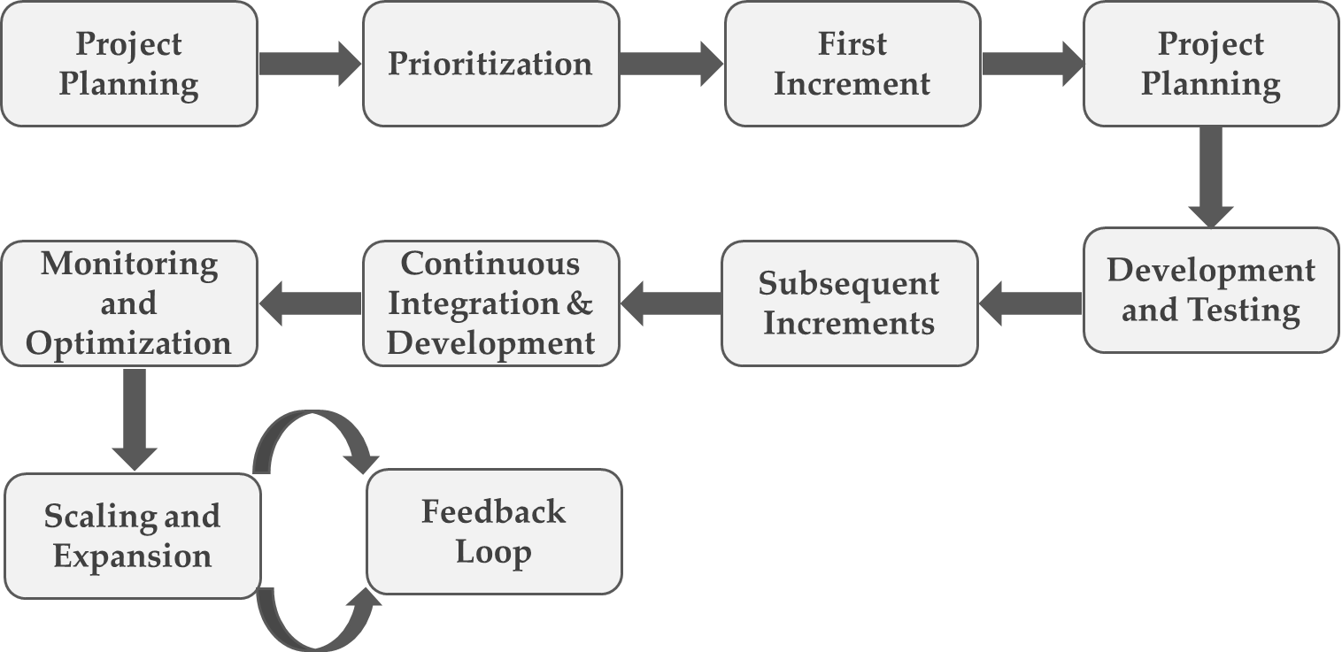
Figure 2. Incremental and iterative app development lifecycle
  - System Architecture and Development Platform
Figure 3 illustrates the architecture of AUMOR. It consists of a remote data server and a wirelessly linked mobile client application that runs on the platform communicating with each other using the JSON protocol. The user engages with the application by using the camera and GPS built into the device to scan the QR code and provide the user's position, respectively. Both the camera and GPS feed their data into the AR Display, which becomes the user's interaction layer with the application. The user request, which includes GPS coordinates or scanned QR information, is structured in JSON format and sent to the remote server. The AR content is stored on a server or repository such as GitHub in JSON-format. The server parses the incoming request, matches the data with the appropriate AR content, and sends a real-time JSON-formatted response containing AR assets such as text, images, or videos. AUMOR parses this response and displays these contents on the mobile display. One of the important features of this app is hot reloading which allows to update the AR dynamically on the server without the need of recompilation saving time, resources, and simplifying content maintenance.
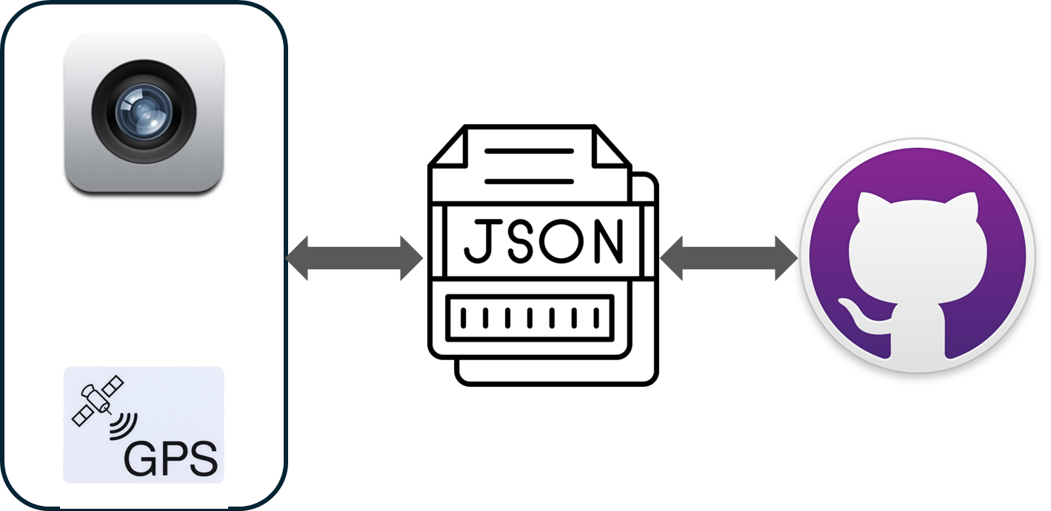
Figure 3. System architecture
The open-source Flutter framework shown in Figure 4 was created by Google for developing the mobile applications [48]. It is chosen for development due to its simplicity, ability to be customized, and scaling making it suitable for quick development. Additionally, it can generate natively compiled applications for different target platforms such as desktop, web, and mobile from a single codebase which can run on both iOS and Android. Its reactive structure allows developers to view changes instantly without losing state by turning on hot reload capabilities [49], [50]. Flutter apps are bundled to the underlying operating system. The entry point is a platform-specific embedder, which manages the message event loop and interfaces with the operating system to provide access to services like input, accessibility, and rendering surfaces. Currently, Java and C++ for Android, Objective-C/Objective-C++ for iOS and macOS, and C++ for Windows and Linux are the languages used to implement the embedder. Using embedder, Flutter code can be used as a module or as the main body of an application. Flutter comes with several embedders for popular target platforms. The core components power all Flutter applications provided by the Flutter engine, which is primarily written in C++. The engine is the foundation for Flutter's main API implementation and is tasked with rasterizing composite scenes whenever a new frame needs to be painted. This includes a Dart runtime and compilation toolchain, text layout, file and network I/O, accessibility capabilities, plugin architecture, graphics functionality (using Impeller on iOS and shortly on Android, and Skia on other platforms), and more.
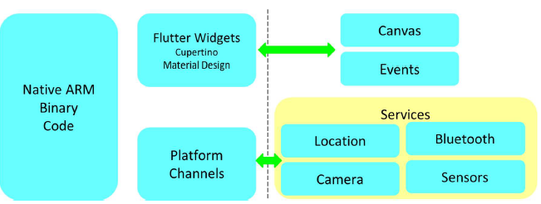
Figure 4. Flutter Mobile Application Framework.
    - User Interface Design and Navigation Flow
The user interface flow of the AUMOR mobile application is shown in Figure 2. The sequence begins with the app icon on the device’s home screen (Figure 5(a)), providing quick access to the system. The panels in Figure 5(b) show the login screen, where users are required to input their email and password credentials, respectively. The log-in interface features a clean and minimalistic design, with a password visibility toggle, “forgot password” option, and a sign-up prompt for new users. Once authenticated, users are directed to the main feature menu (fourth panel). Figure 5(c) shows menu containing four core features such as GPS Guide for navigation, QR Scanner for retrieving contextual information, quiz to reinforce orientation knowledge, and tutorial offering guidance to new users.
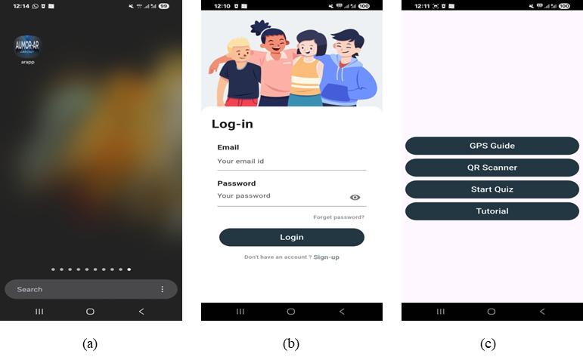
Figure 5. User interface flow of the application (a) AUMOR icon after installation on the phone, (b) login screen, (c) feature panel
  - GPS Integration for Location-Based Services
The app uses GPS-based navigation to deliver information when a student approaches a relevant place on campus. When students approach a point of interest such as a building, restaurant, or outdoor venue, the app activates an AR overlay that anchors to the scene and offers context-specific resources including web links, quick videos, maps, downloadable PDFs, and, where appropriate, simple booking actions (e.g., study rooms or event check-ins). The students can see what matters for the spot in their surroundings resulting in reduced search time and help first-time visitors move confidently between locations and find their way. To build this experience, we marked key campus points of interest and recorded their precise coordinates using Google Maps. Each location was added to a lightweight JSON [51] catalog that stored its name, latitude/longitude, and AR contents to show on request.
The workflow of GPS-based navigation and resource interface of the AUMOR is provided in Figure 6. Workflow of GPS-based navigation and resource interface of the AUMOR When a student enters a geofence, the app displays the location name; tapping it opens an AR panel with the available options to select. For example, a student nearing the Administration Building would see a prompt, and upon clicking, assets are streamed from the web to keep the app small, with essential items cached for spotty connectivity. This GPS-plus-AR approach turns the campus into an interactive guide, providing students with timely and trustworthy information as they navigate their orientation.
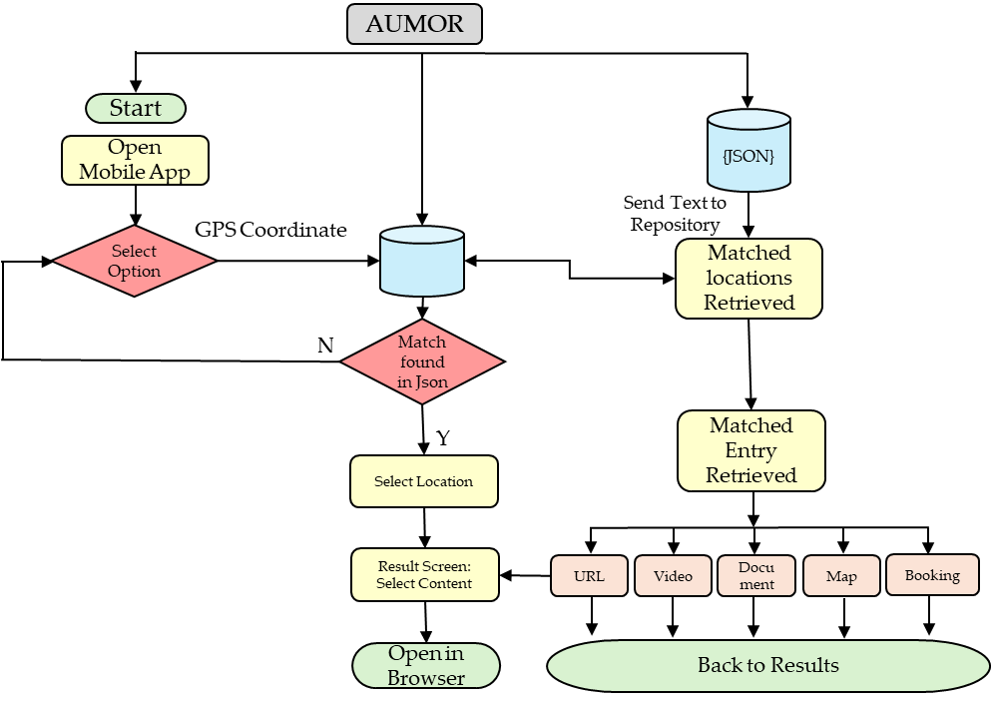
Figure 6. Workflow of GPS-based navigation and resource interface of the AUMOR

The screenshots in Figure 7 illustrate the location-based information system of the AUMOR application. In the first panel shown in Figure 3(a), the system overlays a radar-style marker on the real-world environment to identify nearby locations, such as laboratories, classrooms, cafés, and library. Floating labels provide contextual information such as the name of the building or facility and its distance from the user enabling intuitive and location-aware navigations. Multiple markers in Figure 3(b) allow users to see several locations within the range, such as business buildings, computer labs, tutoring centers, and capstone project rooms providing a comprehensive situational overview, reducing the cognitive load required for navigation in unfamiliar environments. The third panel in Figure 3(c) shows the interactive information panel that is triggered when a user selects a location. This panel provides access to rich multimedia resources, including videos, documents, website links, room maps, and booking options. Such features extend the utility of AR beyond navigation, transforming it into an integrated learning and resource platform for orientation and daily campus use. Although GPS is primarily used for navigation and building-level positioning but at some location where GPS signals are weak or unavailable, the navigation is supported through QR code–based interaction.
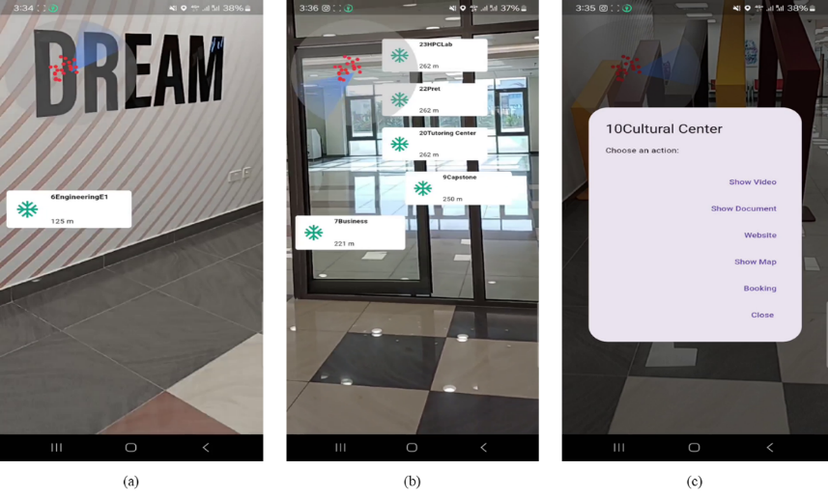
Figure 7. Example of GPS-based navigation and resource interface of the
  - QR Code Implementation for Information Retrieval
The workflow of QR code–based access to resources is shown in Figure 8 We paired AR with QR codes placed on the key equipment encoding a resource name in plain text that the app reads with the camera and resolves against a lightweight JSON catalog mapping that text to an up-to-date content bundle. On scan, the app presents these options as an AR overlay (and accessible list view); tapping it opens the selected asset online. The contents are placed at a single repository to keep the app small while allowing centralized updates without reprinting codes. This scan-to-experience flow delivers just-in-time information for students working with diversified equipment in the lab or looking for staff members. Quick access to resources such as documentation and tutorial etc. helps students perform task without difficulty reducing friction and make learning experience more enjoyable.
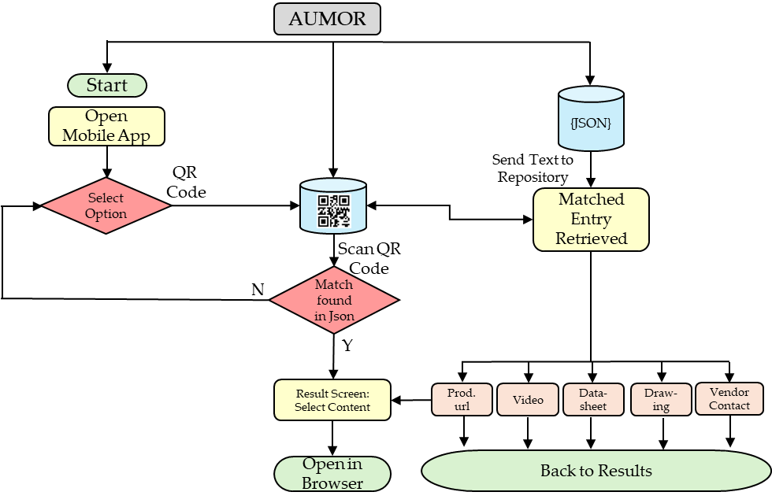
Figure 8. Workflow of QR code–based access to resources

The example QR code enabled information retrieval system designed to facilitate immediate access to technical resources for the Arduino Due board is shown in Figure 4. The QR code placed on the board packaging is shown in Figure 4(a), establishing a direct link between the physical hardware and relevant digital resources. When the QR code is scanned, it is decoded to plain text and system recognizes the device as “Arduino Due” and presents users with a structured set of contents such video tutorials, datasheets, official website access, schematic drawings, and contact details as shown in Figure 4(b). When users select the required option, website for example, they are redirected to the official Arduino documentation portal, where authoritative materials, such as pinout diagrams, datasheets, circuit schematics, and prototyping files, are provided as shown in Figure 4(c) illustrates. This highlights the pedagogical and practical value of embedding QR codes into engineering education contexts, as it effectively bridges physical components with digital learning environments, promotes self-directed inquiry, and ensures learners’ engagement with current and reliable technical content. This functionality exemplifies how QR technology can support efficient knowledge acquisition by minimizing the cognitive and temporal effort required to locate appropriate resources.
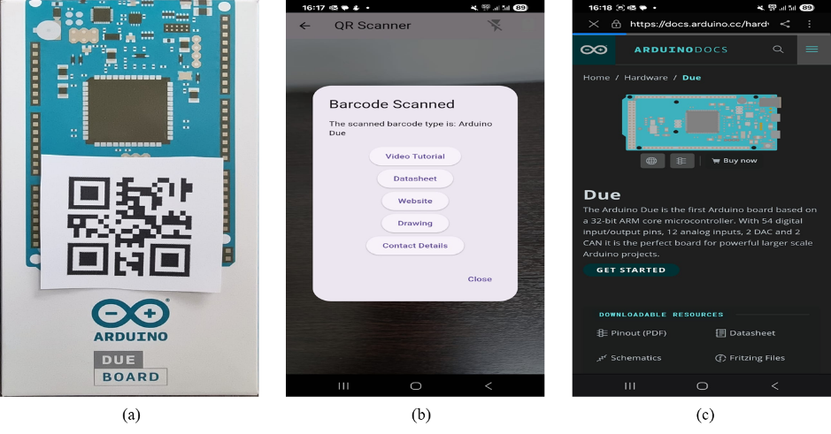
Figure 9. Example of QR code–based access to Arduino Due board resources
- Methodology
  - Research Design and Data Analysis
In this study, we used quantitative data analysis to evaluate user acceptance and perceived effectiveness of the AUMOR application. User perception was measured by using paper-based questionnaire aiming to empirically assess whether the design goals of AUMOR are realized from the users’ perspective. It was supplemented with open-ended questions allowing users to express their opinion freely and revealed deeper insights and contextual nuances that structured survey items might miss.
Quantitative data were analyzed using R statistical software (version 4.0.3). Descriptive statistics were computed to summarize participant demographics and response distributions. The internal consistency reliability was assessed using Cronbach’s alpha, with values exceeding accepted thresholds for exploratory and applied research. This analytical approach provides a transparent and reproducible method for evaluating user acceptance relationships within the proposed framework.

  - Sampling Method and Participant Recruitment
The primary target users of the AUMOR application are students; however, faculty participants were included during this pilot evaluation to provide additional perspectives on usability and informational clarity. The total number of participants was 128, comprising 39.84% males and 60.16% females, with their current academic levels reported in Table 5 below. Most participants were junior (36.72%) or sophomore (31.25 %) students.
Table 5. Participant demographics
Characteristics | Attributes |  |  |  |  |  |  | Total
Participant Gender | Male (51) |  |  |  | Female (77) |  |  | 128
 | 39.84% |  |  |  | 60.16% |  |  | 100%
Participant Age (Years) | Freshmen | Sophomore | Junior | Senior |  | Faculty | Staff | 128
 | 12.50% (16) | 31.25% (40) | 63.72% (47) | 15.63% (20) |  | 3.13% (4) | 0.78% (1) | 100%

Due to the limited number of faculty respondents, the data was analyzed at an aggregate level, and subgroup comparisons between students and faculty were not statistically meaningful. This design choice is now explicitly acknowledged, and future studies will employ stratified sampling and group-wise analysis to examine potential differences between user roles. Also, the participants had prior experience with augmented reality, but it was not used as an inclusion or exclusion criterion for participation. Instead, participants self-reported their familiarity with AR applications as part of the demographic questionnaire. As reported in the Results section, the majority of participants indicated no prior experience with AR, while a smaller proportion reported limited prior exposure. This distribution suggests that the evaluation largely reflects the perceptions of first-time AR users, which is appropriate for a university orientation application intended for new students. This clarification strengthens the generalizability of the findings to typical campus populations.
Participants were recruited using a convenience sampling approach during Spring 2025 semester. Some students were enrolled in the course taught by researchers and participation was strictly voluntary. No academic credit or financial incentives were offered to the participants. The participants were selected in the sequences they contacted. No rewards or compensation were offered for participation, and they were informed that they could withdraw at any time without any consequences. If a participant decided to withdraw the next participant was contacted to take his place. The data was collected outside of teaching and assessment activities. The participating students and facilitators belonged to the engineering and business schools. Though this sampling strategy enabled efficient access to participants, it may introduce sampling bias and may limit generalizability. We explicitly acknowledged this limitation. Future work will address this by employing broader recruitment strategies, such as cross-departmental or multi-institutional sampling, to enhance external validity and reduce potential bias.

  - Research Procedure
In case of students agreeing to take part, a meeting was arranged in which the participant and researchers were present who performed the evaluation and described the research and the procedure for carrying out the test to the participant(s). Respondents were briefed about the study purpose, anonymity, and consent before participation. Participants were made aware that their involvement in the study was entirely voluntary and that they might leave at any moment without facing any repercussions. They were provided with an Android smartphone with a pre-installed orientation application (AUMOR) inside the campus. The application includes a video tutorial to guide students and reduce their dependence on external assistance. After using the application, the participants were demanded to fill in a paper-based form evaluating comfort, usefulness, and helpfulness. The data was collected over a period of one month during summer 2025.

  - Instrument Validity and Reliability
We used a structured questionnaire as a primary instrument for collecting data which was adopted from established and validated instrument reported in literature. It was modified to align with the university orientation and AR application context. The instrument combined quantitative and qualitative items to get user feedback and assess user perceptions and experiences. The survey used in this research was derived from TAM original measurement scales [52] as well as from other literatures [2], [15], [22], [53], [54], [55], [56]. The final instrument contained 27 items whose wording is provided in Table 2 for reference.

Table 2. Questionnaire Used in User Testing
Q1 | Gender
Q2 | Current Academic Level
Q3 | How often do you use mobile applications for educational purposes?
Q4 | Have you used an AR-based application before?
Q5 | The AR application helps me better understand the university campus layout.
Q6 | The AR application provides useful information about campus facilities
Q7 | The AR application improves my overall orientation experience.
Q8 | Using the AR application saves time in finding important campus locations.
Q9 | The AR application enhances my confidence in navigating the campus.
Q10 | It is easy to find information about different locations using the AR application.
Q11 | The AR application is simple to learn and use.
Q12 | I do not need additional instructions to understand how to use the AR app.
Q13 | The AR app responds quickly to my interactions (e.g., tapping, swiping).
Q14 | The layout and design of the AR application are user-friendly.
Q15 | I find it difficult to use the AR application.
Q16 | I find the AR application to be a fun way to explore the campus.
Q17 | I enjoy using the AR application during orientation.
Q18 | I believe using the AR app is a good idea for campus orientation.
Q19 | I feel confident when using the AR application to navigate the university.
Q20 | I will recommend this AR application to other students or new entrants.
Q21 | I would prefer using an AR application over traditional methods for orientation.
Q22 | I plan to continue using the AR application during my time at the university.
Q23 | Which features of the AR app did you use the most? (Select all that apply)
Q24 | How frequently did you use the AR application during your orientation?
Q25 | How likely are you to continue using this AR application after orientation?
Q26 | What kind of information would you like to see on the application?
Q27 | What will you suggest improving this application?
All Likert items used a 5-point scale: 1 = Strongly Disagree to 5 = Strongly Agree.

  - Research Ethics
This study involved human participants and required approval from the concerned authorities. The survey was approved by the research committee at AUM. The research required interactions faculty conducting the survey and the participants. Therefore, the researcher was aware of the participants’ identities, and anonymity was not possible. The questionnaire provided to the participants was anonymous and did not obtain any information that could help to identify them.
- Results
In this section, we present the evaluation results of AUMOR application. The app was tested in real-life and data collected was analyzed using R software (version 4.0.3). The internal consistency of the survey was very good, with a Cronbach’s alpha of .928.
The app was tested in real-life with screenshots provided in Figure 10 showing navigation in Figure 10 (a) and (b), QR code in Figure 10 (c) and (d), and quiz in (Figure 10 (e) and (f)).
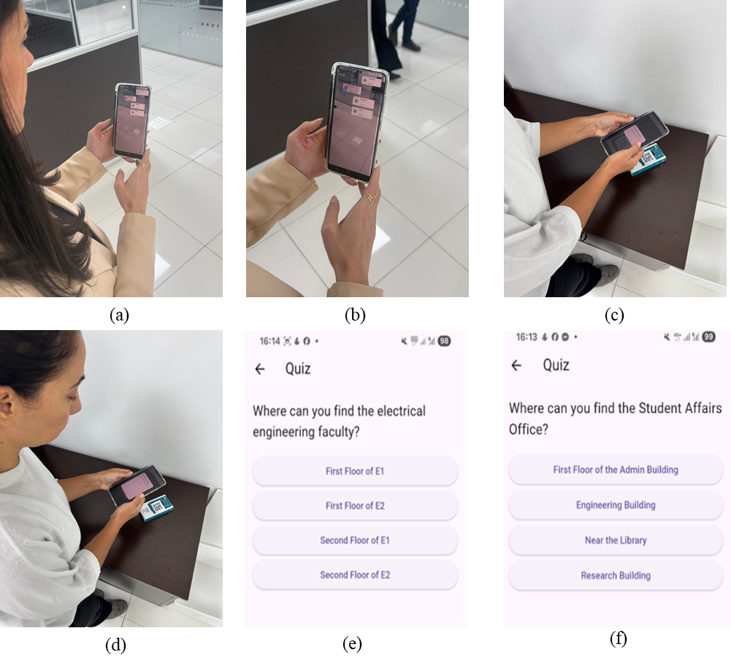
Figure 10. Real-life testing of AUMOR (a) and (b) showing GPS navigation, (c) and (d) showing QR code scanning, (e ) and (f) quiz
Approximately one-third of the participants (32.81%, n=42) reported using mobile applications for educational purposes often, and over a third (35.15%, n=45) said they sometimes did so and only a small minority reported minimal engagement, with 4.69% using them rarely and 1.56% never using them. Regarding familiarity with AR, most respondents (57.03%, n=73) have not used an AR app before, while 40.63% (n=52) reported prior AR use, and 2.34% (n=3) did not answer. This means that the proposed AR app is new to many students, which helps explain the sizable neutral responses in ease-of-use/usefulness items; many are first-time users still forming opinions.
The breakdown of the user responses is shown in Figure 11. The questions are in Figure 11 (a) are related to the usefulness of the application. Most of the students found the AUMOR was useful for understanding the university campus layout (60.16%, n=77), finding useful information about campus facilities (75%, n=96), and overall orientation experience (57.82%, n=74). For most participants (74.22%, n=95), using the AR app saved time in finding important campus locations, and it helped with confident campus navigation (57.03%, n=73).
Figure 11 (b) shows a breakdown of the questions related to the ease of use and most of the survey participants found information about different campus locations easily using the application (71.88%, n=92). They also found the AUMOR app simple to learn and use (70.32%, n=90) and did not require additional instructions to understand how to use the application (49.22%, n=63). The AR app was quick to respond according to 54.68% (n=70) of the survey participants, with a user-friendly layout and design (66.41%, n=85), and it was not difficult to use (52.35%, n=67).
The questions in Figure 11 (c) reflect the users’ attitude towards using the application and the results were broadly positive. Students strongly endorsed the concept, with 75.79% (n=97) believing that using the AUMOR app for orientation was a good idea, with only 2.34% (n=3) disagreeing and 18.75% (n=24) neutral. They also found it engaging, as 71.10% (SA+A, n=31) said that the app was a fun way to explore the campus, while only 8.59% disagreed and 17.19% were neutral. Personal experience was solid but mixed with 58.60% (n=75) feeling confident when navigating the app, while 30.47% (n=39) were neutral and only 7.04% disagreed. Similarly, 53.91% (SA+A, n=69) enjoyed using it during orientation, with a relatively high 35.94% (n=46) neutral and 6.25% (n=8) negative responses. Non-responses were small (3% for each item). In short, students demonstrate the acceptance of the idea AR, but a sizeable neutral block on confidence and enjoyment suggests room for improvement to convert the undecided into enthusiastic users.
The response in Figure 11 (d) are related to user behavior towards the use of application which are are strong overall as 75.0% (n=96) would recommend the AUMOR app to other students, with only 7.03% (n=9) negative and 14.84% (n=19) neutral. Preference over traditional orientation methods were positive but more mixed with 53.9% (n=69) favoring the AR approach, while 29.69% (n=38) are neutral and 11.72% (n=15) disagree, suggesting many are open to AR but still comparing it with familiar formats. The intent to continue using the app during university was similarly moderate with 52.35% positive (SA+A, n=67), 32.81% (n=42) neutral, and 10.16% (n=13) negative.
The breakdown of the usage of the different features of the AUMOR application is presented in Figure 11 (e). We observed that the survey participants used the app mainly for campus navigation (51.56%, n=66) and for finding information about laboratory equipment (39.06%, n=50). Approximately one-third of the participants used the AR app to locate specific buildings or departments (29.69%, n=38), gather information on student services (28.91%, n=37), and access event schedules (27.34%, n=35). Some participants were also interested in virtual campus tours (18.75%, N=24).
Figure 11 (f) shows the intended use of the AR application after orientation. Most of the survey participants were likely or very likely to continue using the AR application after the orientation (57.03% of the total).
We performed an inductive thematic analysis to the open-ended item “What kind of information would you like to see on the application?” We also performed an inductive thematic analysis to the second open-ended item “What will you suggest improving this application?” The responses were multi-coded, total exceeding 100% and outcomes are as follows.
- Real-time status, Live status features
- Content expansions (Academic info and student services, hours, booking of utilities, events and schedules)
- Navigation and wayfinding
- iOS availability
- Application features (simplified UI/US, performance, reliability & accuracy)

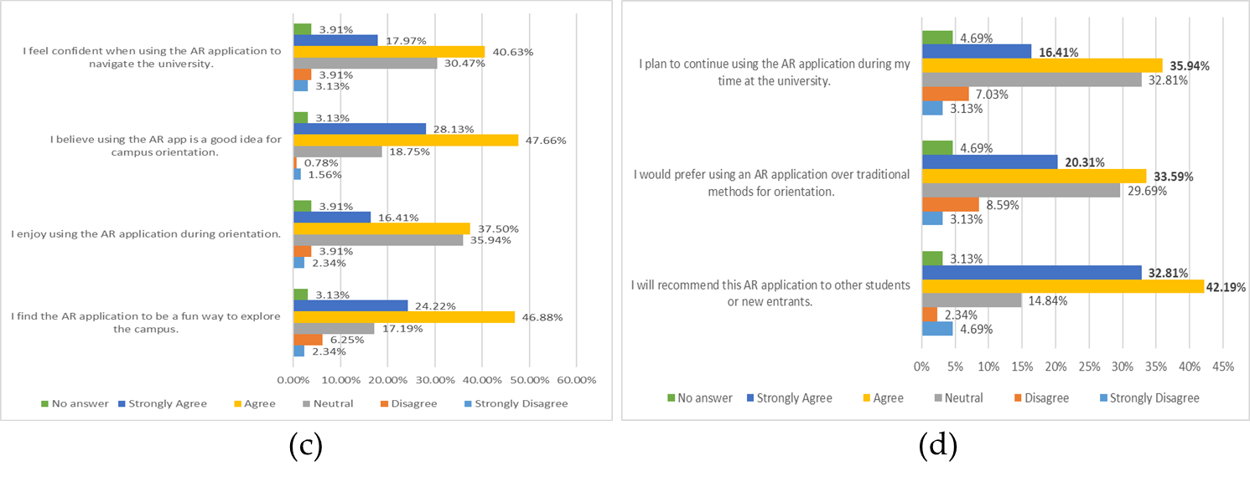
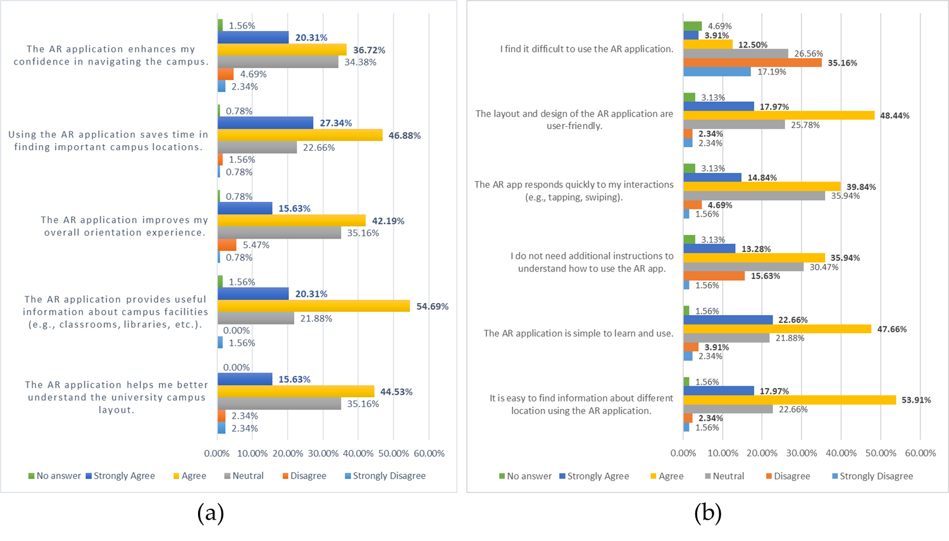
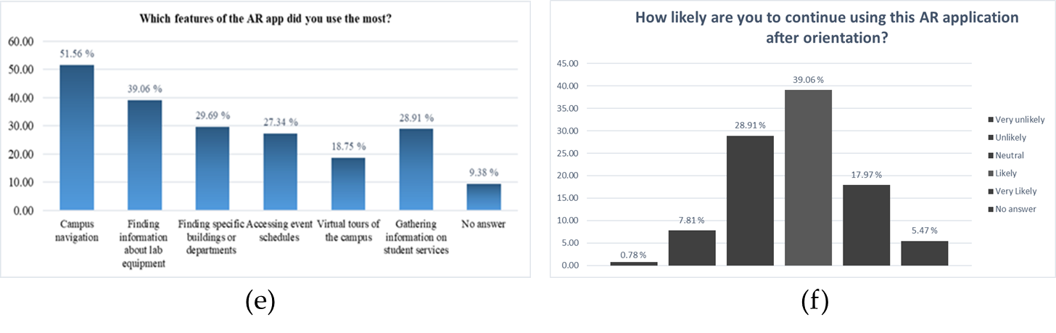
Figure 11. Breakdown of user responses of the questions related: (a) usefulness of the AR application, (b) ease of use, (c) user attitude to use, (d) intention to use (e) usage of the different features of the AR application, and (f) user of AUMOR after orientation.

- Discussion
The evaluation results presented in previous section confirm the potential of augmented reality combined with GPS and QR code technologies to improve the orientation experience of new students. The user perceived the application highly useful in terms of timesaving and facility information, reflecting that application successfully provides access to contextual information instantly at the point of need. This is compatible with earlier findings which suggest that mobile applications are valuable when they reduce effort and provide ease in performing real-world tasks. However, low scores for confidence in navigation and improvement in overall orientation experience were more moderate. This suggests that the application delivers the information but does not offer complete way of finding solution for visitors.
The user also found the application simple to learn, intuitive for accessing information, and has user-friendly layout. These findings align with the core principles of the TAM, which emphasizes that PEOU is a key factor that influences the user acceptance and sustained engagement with technology [52]. Many other studies suggest that ease of use significantly predicts BI and AU, especially in educational technology contexts [12], [57]. Specifically, in AR-based learning environments, students who perceive systems as easier to navigate are more likely to develop positive attitudes and trust in the system [57]. Relatively weaker scores in system responsiveness and the expressed need for support indicate the areas needing the improvement. These concerns are coherent with outcomes of earlier research that emphasize the importance of system responsiveness and structured onboarding in AR applications to reduce cognitive load and anxiety [58], [59]. Since students were not familiar with AR technologies, the integration of improved tutorials could increase user because structured support materials and smooth interface feedback loops bridge initial resistance and improve the perceived ease of use [60], [61]. Furthermore, poor internet quality due the surrounding building might also contribute to the low scores to the system responsiveness. This could be overcome by making the contents available offline by embedding them in the application thus improving the response time of the system by removing dependence on internet and eliminating the request and response time altogether. But it comes at the cost as it can significantly increases the size of the application. Furthermore, it results in loss of flexibility and efficiency as it is not be possible to update or modify the content centrally. A recompilation of the application by developer and update on mobile from the user is needed as a result of any change in the content.
The user strongly endorsed AUMOR as nearly three-quarters of respondents favoured that using the app was a good idea for orientation, and a fun way to explore campus. These findings highlight that students view AR as functional and enjoyable, supporting the premise that perceived enjoyment can reinforce acceptance, as noted in the extended versions of the Technology Acceptance Model 3 (TAM3). However, indicators of confidence and personal enjoyment were somewhat lower with a sizable proportion of neutral responses suggesting that some students remain cautious or undecided about its reliability and personal value for practical use. Such hesitation is often linked to first-time exposure to AR technologies, as many of the participants never used AR before. Another reason for the low score can be the contribution of the senior students who have spent a lot of time at the university and do not perceive it the same way as the freshmen. This can be improved by including micro-onboarding, optimizing the performance to reduce lag, and improving indoor navigation accuracy. These measures can change neutral attitudes into more enthusiastic adoption, maximizing the impact of AUMOR.
The outcomes of intention to use were similarly promising as most of the students reported that they recommend the AR app to their peers, demonstrating a strong potential. More than half of the students expressed a preference for AR-based orientation over traditional methods and have the intentions to use it during their studies. These results suggest that AUMOR has a clear pathway for sustained adoption, provided that its reliability and relevance continue to improve. But a large number of students were for both preference and continued which requires improvements so that it could be more beneficial students’ daily academic lives. Inclusion of extra feature such as real-time event reminders, updates on facilities, and academic service integration (grades, office hours) could embed the app into routine student practice. Aligning AR content with students’ immediate academic and administrative needs may transform the app from a one-time orientation aid to a long-term companion throughout their university journey. In line with TAM, the BIU findings underscore that positive attitudes and perceived usefulness drive the intention to use. By taking advantage of on high recommendation rates and addressing areas of concerns, universities can ensure that AUMOR become an integral part of the student experience, rather than a novelty used only at the start of the academic year.
The analysis of student feedback highlighted five major domains of desired mobile application features for enhancing the campus experience. Real-time status and availability information was the most emphasized with students requesting live updates on parking status, building occupancy, cafeteria menus, and utilities such as power or air conditioning status. These are crucial because they eat up a lot time while looking for parking or waiting in queues to buy something from cafeteria. These features reflect the increasing demand for improved mobility and decision-making in real time [62].
“Available parking; subway is crowded or not”; “real time cafeteria menus”.
The content expansions was another theme calling for more comprehensive coverage of office locations, hours, semester dates, and class times as apparent from the following remarks from the students:
“Access to information about events happening at AUM”; “reminders about assignments and events”
“Quick information about the office hours of faculty, information about course projects”
“Booking of study rooming library”; “booking of seminars and workshops”
“FAQ section for new students”; “updated semester schedule”
Such expansions align with research showing that information-rich applications increase perceived usefulness and institutional trust [63]. Inclusion of features such as centralized access to event dates, semester-specific schedules, and integrated reminder about functions, aligning with prior findings that calendar-linked notifications significantly improve student engagement [64]. Meanwhile, booking and utilities (~7%) focused on study room reservations and workshop/lab bookings, functions that are increasingly integrated into smart campus platforms [33]. The students also expressed profound interest in getting academic information and student services, including grades, assessment feedback, project updates, and faculty office hours [65]. This resonates with previous research indicating that academic transparency and immediate access to information strongly influence students’ satisfaction with learning technologies [66]. The availability of office hours is important for students as it is helpful to get personalized help from the teacher, get feedback, and build strong relationships. But integration of academic information such as the student grades as it is not feasible due to sensitivity of the data and may face risk of security as it is highly confidential. Therefore, students need to access this information through official portal. Finally, help, and usability (approx. 12%) were cited, including requests for clearer information, full campus guides, and FAQ sections, which were particularly valuable for first-year students adapting to a new academic environment [63]. These facilities are particularly in demand when an assessment is due.
Navigation and wayfinding were another prominent need (~25–30%) as mentioned by students in their responses:
“Campus navigation”; “clicking on class should show me the way”; “places of every building”
In large university campuses, students often move from one class to another class in their busy schedule. Navigating through unfamiliar places puts an extra pressure on us to go to wrong places and miss the class. where students envisioned location-aware routing linked directly to their class schedules, echoing evidence that location-based services improve campus accessibility and efficiency [67], [68]. Although finding solutions are provided in this application but a more direct or map-based approach is more appreciated by the students.
Performance, reliability, accuracy, UI/UX simplification, and modernization (approx. 25%) were also highlighted, with students demanding faster load times, bug fixes, and more precise locations and AR features. The students requested clearer layouts, organized lists, and more interactive designs. This is clear from student responses given below:
“Quicker response, quicker updates”, “give precise locations”,
Research on learning technologies confirms that well-structured and aesthetically modernized interfaces reduce cognitive load and increase user engagement [69]. The main reason for delayed response is the quality of internet service, which might vary depending on the location and the service provider. Also, the GPS service is not precise at some time due to signal blockage, multipath interference, and atmospheric conditions. Prior studies have similarly shown that system responsiveness and reliability are critical determinants of user satisfaction and continued use of educational apps [70]. The GPS precision can be maximized by turning power saving mode and enabling high accuracy and keeping the software up to date.
iOS availability and distribution emerged as the most frequently mentioned (approx. 35%), with students requesting that the app be made accessible via the Apple App Store to support iPhone users as evident from the following student comments:
“Upload it in the Apple…”, “make it for iOS”, “allow iPhone users to download it”
This aligns with broader evidence showing that cross-platform compatibility significantly increases adoption and inclusivity in mobile applications for higher education [71]. The demand basically stems from the fact that most of the students possess Apple phone. Although iOS apps are secure and provide enhanced user experience, but stringent App Store leads to longer approval times and offer limited customization at the same time. The availability of cheap Android phones and open-source development platforms was main reason behind its selection as the target platform.
One of the main strengths of this application is the integration of GPS and QR code scanning with AR overlays, which provide students with information immediately at the point of need. This design was appreciated for its ability to reduce the time spent searching for facilities and resources, which aligns well with the goals of orientation programs. Its incremental development model also allows for iterative improvements and scalability. From a maintenance point of few, the contents delivered can be modified and updated without the need for recompilation making housekeeping of the application easy. However, it also suffers from some weaknesses as basic navigation has limited value for students, especially the senior students who were already familiar with the campus. Moreover, lag in AR responsiveness and lack of precision on some occasions in location detection, reduce user confidence. Accessibility gaps were also highlighted, especially the lack of iOS compatibility, which was one of the most common suggestions for improvement by the participants. These weaknesses confirm the findings of previous AR campus systems, which frequently encountered barriers related to technical stability, inclusivity, and scalability [72]. Because participants were recruited using convenience sampling from a single institution, the findings should be interpreted as indicative rather than fully generalizable, motivating future large-scale and multi-campus evaluations. AUMOR also supports SDG 4 (Quality Education), which emphasizes inclusive and equitable access to lifelong learning [73].
AUMOR offers several advantages when compared with earlier AR-based orientation initiatives applications. Early systems, such as those at Columbia University and Fu-Jen Catholic University, focused on head-mounted displays or AR visualization of campus landmarks thus require specialized hardware and offered limited scalability. More recently, Chung Hua University and the University of Quindío have used multimedia and 3D directional boards, but they lack GPS precision and QR code versatility. AUMOR’s hybrid approach, on the other hand, uses smartphone with both GPS and QR-triggered AR overlays successful achieving stronger accessibility and reducing the dependence on expensive hardware. Furthermore, AUMOR’s evaluation of 128 participants adds to the literature by providing a large-scale, empirical dataset. While studies at universities such as Bowling Green State or Haaga-Helia UAS focused on niche features (cultural exploration or missed orientation catch-up), AUMOR demonstrates the feasibility of embedding AR into mainstream orientation practices in higher education.
AUMOR complements or substitute traditional orientation programs which are often resource-intensive and costly. Second, the open-ended feedback from students underscores the demand for richer real-time functionality, including live updates on parking and event as well as integration with academic services. Incorporating these features would extend the use beyond orientation into everyday life of a student fostering a long-term engagement. Also, the results reinforce that technology adoption not only depends on novel features but also on reliability, inclusivity, and relevance. Therefore, addressing performance stability, expanding platform availability, and layering personalized academic content are critical steps for boosting the impact.

- Conclusion
This study presents the design, implementation, and evaluation of the AR-based mobile to support student orientation through the integration of GPS, and QR code technologies. This application addresses the common challenges faced by the students who feel disoriented and time-pressed in large universities by providing location-based information as well as information about the equipment when performing experiments in the lab. The evaluation results indicated that students found the system useful for saving time and accessing facility information due to its clean design and simple interface contributing to their perceptions of ease of use. The interactive features, such as floating labels, multimedia resources, and quizzes, highlight engagement and learning potential of the application. The research contributes to the field of educational technology, advancing understanding of AR-assisted learning environments and technology adoption in higher education. The findings suggest that student services offices can integrating AR applications into orientation activities to provide interactive experiences that promote engagement. Despite its strengths, the areas for improvement include the need for performance optimization, cross-platform availability (iOS compatibility), and personalized content delivery. Compared with previous AR-based orientation systems, AUMOR advances the field by combining affordability, scalability, and validation in a real-world context. Future work should focus on improving the application with real-time event updates, academic service integration, and accessibility options to support diverse student populations. It will also address the limitation of generalizability by recruiting larger and more balanced subgroups and conducting separate analyses for students and faculty, as well as controlling comparisons between novice and experienced AR users. The AUMOR has the potential to evolve into a comprehensive digital campus companion improved student engagement, time management, and well-being of students.

Author Contributions: Conceptualization, M.N. and M.O.; methodology, M.N., M.O., P.A., and H.O.; software, M.N., M.O., and P.A.; validation, M.N., M.O., P.A., and H.O., and S.B.; formal analysis, M.N., M.O., and P.A.; investigation, M.N., M.O., P.A., and H.O., and S.B.; resources, M.N., M.O., and H.O.; data curation, P.A., and H.O.; writing—original draft preparation, M.N., M.O., P.A., H.O., and S.B.; writing—editing and review, M.N., M.O., P.A., H.O., and S.B.; visualization, M.N., M.O., P.A., H.O., and S.B.; supervision, M.N. and M.O.; project administration, M.N; All authors have read and agreed to the published version of the manuscript.”
Funding: This research received no external funding
Institutional Review Board Statement: The survey was approved by the Research Committee at the American University of the Middle East (AUM), Kuwait (Project Identification Code: 2024_2025_SV001. Date of Approval: June 18, 2025).
Informed Consent Statement: Informed consent was obtained from subjects involved in the study.
Data Availability Statement: Data available on request.
Conflicts of Interest: The authors declare no conflicts of interest.

References
[1] M. Nadeem, M. Oroszlányová, A. Lushi, and W. A. Farag, “Bridging the gap: Analyzing skill demands in Kuwait’s electrical engineering job market to enhance employability of graduates,” Industry and Higher Education, vol. 39, no. 5, pp. 550–567, 2025.
[2] M. Nadeem, A. Chandra, A. Livirya, and S. Beryozkina, “AR-LaBOR: Design and assessment of an augmented reality application for lab orientation,” Educ. Sci. (Basel)., vol. 10, no. 11, p. 316, 2020.
[3] C. Feilberg, “In deep water: university students’ challenges in the processes of self-formation, survival or flight,” in Educational Dilemmas, Routledge, 2019, pp. 126–138.
[4] S. P. Moe, “Design and evaluation of a user-centric information system: Enhancing student life with mobile computing,” 2009, Institutt for datateknikk og informasjonsvitenskap.
[5] M. Mohzana, “The impact of the new student orientation program on the adaptation process and academic performance,” International Journal of Educational Narratives, vol. 2, no. 2, pp. 169–178, 2024.
[6] Department of Education, “Student services and amenities fee (SSAF) and SA-HELP,” Australian Government.
[7] R. Rashid, N. Annamalali, H. Saed, B. Yassin, and O. Alsmadi, “Developing an interactive university orientation app: Potential users’ feedback,” International Journal of Interactive Mobile Technologies, vol. 15, no. 22, pp. 165–171, 2021.
[8] P. Milgram, H. Takemura, A. Utsumi, and F. Kishino, “Augmented reality: A class of displays on the reality-virtuality continuum,” in Telemanipulator and telepresence technologies, Spie, 1995, pp. 282–292.
[9] Fortune Business Insights, “ugmented Reality Market Size, Share, Growth | Forecast [2024-2032],” 2024.
[10] A. Ulucan, K. B. Atici, and S. B. Sarac, “A university-wide orientation course timetabling model and its modification for pandemic period,” Opsearch, vol. 60, no. 4, pp. 1575–1602, 2023.
[11] N. Crozier, “Designing effective online orientation programs for first-year university students,” 2021.
[12] S. O. Mercer and A. La Marca, “Exploring Future Teachers’ Acceptance of Wearable Technologies for Anxiety and Stress Management: A TAM-Based Study”.
[13] Q. N. Naveed, H. Choudhary, N. Ahmad, J. Alqahtani, and A. I. Qahmash, “Mobile learning in higher education: A systematic literature review,” Sustainability, vol. 15, no. 18, p. 13566, 2023.
[14] L. Briz-Ponce, A. Pereira, L. Carvalho, J. A. Juanes-Méndez, and F. J. García-Peñalvo, “Learning with mobile technologies–Students’ behavior,” Comput. Human Behav., vol. 72, pp. 612–620, 2017.
[15] M. Nadeem, M. Lal, J. Cen, and M. Sharsheer, “AR4FSM: Mobile augmented reality application in engineering education for finite-state machine understanding,” Educ. Sci. (Basel)., vol. 12, no. 8, p. 555, 2022.
[16] A. Dwinggo Samala, L. Bojić, D. Bekiroğlu, R. Watrianthos, and Y. Hendriyani, “Microlearning: Transforming education with bite-sized learning on the go—insights and applications,” International Journal of Interactive Mobile Technologies (iJIM), vol. 17, no. 21, 2023.
[17] V. P. Chandran et al., “Mobile applications in medical education: A systematic review and meta-analysis,” PLoS One, vol. 17, no. 3, p. e0265927, 2022.
[18] M. Nadeem, W. Farag, Z. Uykan, and M. Helal, “Applications of machine learning in operational aspects of academia: a review,” International Journal of Evaluation and Research in Education (IJERE), vol. 13, no. 5, pp. 2843–2863, 2024, doi: http://doi.org/10.11591/ijere.v13i5.29324.
[19] C. J. Hegarty, “The global positioning system (GPS),” in Springer handbook of global navigation satellite systems, Springer, 2017, pp. 197–218.
[20] T. J. Soon, “QR code,” synthesis journal, vol. 2008, no. 3, pp. 59–78, 2008.
[21] C. Bhadane and K. Shah, “Context-aware next location prediction using data mining and metaheuristics,” Evol. Intell., vol. 14, no. 2, pp. 871–880, 2021.
[22] F. Alsubaiei, A. Alhendi, K. Alkhalifa, S. Alsharaf, A. Alfoudari, and M. Nadeem, “OGAR: Augmented Reality Application for Assisting Workers in the Oil and Gas Industry,” Proceedings of the IEEE International Multi Topic Conference, INMIC, no. 2024, 2024, doi: 10.1109/INMIC64792.2024.11004414.
[23] D. Li, M.-C. Chuah, and L. Tian, “Lehigh explorer augmented campus tour (LACT),” in Proceedings of the 2014 workshop on Mobile augmented reality and robotic technology-based systems, 2014, pp. 15–16.
[24] C. G. Low and Y. L. Lee, “SunMap+: An intelligent location-based virtual indoor navigation system using augmented reality,” 2014.
[25] S. Feiner, B. MacIntyre, T. Höllerer, and A. Webster, “A touring machine: Prototyping 3D mobile augmented reality systems for exploring the urban environment,” Personal Technologies, vol. 1, pp. 208–217, 1997.
[26] T.-L. Chou and L.-J. ChanLin, “Augmented reality smartphone environment orientation application: a case study of the Fu-Jen University mobile campus touring system,” Procedia-Social and Behavioral Sciences, vol. 46, pp. 410–416, 2012.
[27] J. Garay-Cortes and A. Uribe-Quevedo, “Location-based augmented reality game to engage students in discovering institutional landmarks,” in 2016 7th International Conference on Information, Intelligence, Systems & Applications (IISA), IEEE, 2016, pp. 1–4.
[28] N. Nguyen, T. Muilu, A. Dirin, and A. Alamäki, “An interactive and augmented learning concept for orientation week in higher education,” International Journal of Educational Technology in Higher Education, vol. 15, no. 1, pp. 1–15, 2018, doi: 10.1186/s41239-018-0118-x.
[29] F. G. Hamza-Lup, J. P. Rolland, and C. Hughes, “A distributed augmented reality system for medical training and simulation,” arXiv preprint arXiv:1811.12815, 2018.
[30] C. Carbonell Carrera and L. A. Bermejo Asensio, “Landscape interpretation with augmented reality and maps to improve spatial orientation skill,” Journal of Geography in Higher Education, vol. 41, no. 1, pp. 119–133, 2017.
[31] J. T. Chao, L. Pan, and K. R. Parker, “Campus event app-new exploration for mobile augmented reality,” Issues in Informing Science and Information Technology, vol. 11, no. 1, pp. 1–11, 2014.
[32] K.-M. Yu, J.-C. Chiu, M.-G. Lee, and S.-S. Chi, “A mobile application for an ecological campus navigation system using augmented reality,” in 2015 8th International Conference on Ubi-Media Computing (UMEDIA), IEEE, 2015, pp. 17–22.
[33] B. Al Delail, L. Weruaga, and M. J. Zemerly, “CAViAR: Context aware visual indoor augmented reality for a university campus,” in 2012 IEEE/WIC/ACM International Conferences on Web Intelligence and Intelligent Agent Technology, IEEE, 2012, pp. 286–290.
[34] F. D. Giraldo, E. Arango, C. D. Cruz, and C. C. Bernal, “Application of augmented reality and usability approaches for the implementation of an interactive tour applied at the University of Quindio,” in 2016 IEEE 11th Colombian Computing Conference (CCC), IEEE, 2016, pp. 1–8.
[35] U. Özcan, A. Arslan, M. İlkyaz, and E. Karaarslan, “An augmented reality application for smart campus urbanization: MSKU campus prototype,” in 2017 5th International Istanbul Smart Grid and Cities Congress and Fair (ICSG), Ieee, 2017, pp. 100–104.
[36] M. Batty and P. Kyaw, “Vector-based location finding for context-aware campus,” in 2009 Fifth International Conference on Wireless and Mobile Communications, IEEE, 2009, pp. 116–121.
[37] A. Walsh, “QR Codes–using mobile phones to deliver library instruction and help at the point of need.,” Journal of information literacy, vol. 3, no. 1, pp. 55–65, 2010.
[38] C. Sur, “Use of QR Codes in Promoting Library Resources and Services: A Study of Review of Literature”.
[39] M. Padmaja, K. Geethasri, J. S. Kousik, M. Vaishnavi, B. K. Sai, and D. L. Nayak, “Campus Routing Using QR Code,” in Journal of Physics: Conference Series, IOP Publishing, 2022, p. 12060.
[40] V. P. Dennen, S. Hao, S. Lee, and T. Lim, “Virtual Enhancement to Physical Spaces: A QR code based orientation game,” The Journal of Emerging Learning Design, vol. 2, no. 1, 2015.
[41] J. Lave, “Situating learning in communities of practice.,” 1991.
[42] M. Dunleavy, C. Dede, and R. Mitchell, “Affordances and limitations of immersive participatory augmented reality simulations for teaching and learning,” J. Sci. Educ. Technol., vol. 18, no. 1, pp. 7–22, 2009.
[43] R. C. Atkinson and R. M. Shiffrin, “Human memory: A proposed system and its control processes,” in Psychology of learning and motivation, vol. 2, Elsevier, 1968, pp. 89–195.
[44] H.-K. Wu, S. W.-Y. Lee, H.-Y. Chang, and J.-C. Liang, “Current status, opportunities and challenges of augmented reality in education,” Comput. Educ., vol. 62, pp. 41–49, 2013.
[45] E. Tenner, “The design of everyday things by Donald Norman,” Technol. Cult., vol. 56, no. 3, pp. 785–787, 2015.
[46] J. L. Bacca Acosta, S. M. Baldiris Navarro, R. Fabregat Gesa, and S. Graf, “Augmented reality trends in education: a systematic review of research and applications,” Journal of Educational Technology and Society, 2014, vol. 17, núm. 4, p. 133-149, 2014.
[47] D. R. Montello, “Cognition of geographic information,” in A research agenda for geographic information science, CRC Press, 2004, pp. 61–91.
[48] A. Tashildar, N. Shah, R. Gala, T. Giri, and P. Chavhan, “Application development using flutter,” International Research Journal of Modernization in Engineering Technology and Science, vol. 2, no. 8, pp. 1262–1266, 2020.
[49] A. TĂBUȘCĂ, C. Coculescu, and M. Pîrnău, “FLUTTER TECHNOLOGY AND MOBILE SOFTWARE APPLICATIONS.,” Journal of Information Systems & Operations Management, vol. 16, no. 2, 2022.
[50] W. Wu, “React Native vs Flutter, Cross-platforms mobile application frameworks,” 2018.
[51] P. Bourhis, J. L. Reutter, and D. Vrgoč, “JSON: Data model and query languages,” Inf. Syst., vol. 89, p. 101478, 2020.
[52] F. D. Davis, “Perceived usefulness, perceived ease of use, and user acceptance of information technology,” MIS quarterly, pp. 319–340, 1989.
[53] K. Mouloudj et al., “Factors influencing the adoption of digital health apps: an extended technology acceptance model (TAM),” in Integrating Digital Health Strategies for Effective Administration, IGI global, 2023, pp. 116–132.
[54] H. Jeong, “An investigation of user perceptions and behavioral intentions towards the e-library,” Library Collections, Acquisitions, and Technical Services, vol. 35, no. 2–3, pp. 45–60, 2011.
[55] N. Kim, Y. Park, and D. Lee, “Differences in consumer intention to use on-demand automobile-related services in accordance with the degree of face-to-face interactions,” Technol. Forecast. Soc. Change, vol. 139, pp. 277–286, 2019.
[56] V. Venkatesh, M. G. Morris, G. B. Davis, and F. D. Davis, “User acceptance of information technology: Toward a unified view,” MIS quarterly, pp. 425–478, 2003.
[57] D. P. Putri, “Augmented Reality Implementation in Financial Regulatory Education for Indonesian High School Students,” Augmented Reality Implementation in Financial Regulatory Education for Indonesian High School Students.
[58] S. B. Bello, M. S. Abdurrahman, and U. S. Bebeji, “Artificial Intelligence in legal Education: Perceptions of ease of use and usefulness of CHATGPT among undergraduate law Students of Ahmadu Bello University, Zaria,” LexScriptio A Journal of the Department of Jurisprudence and Public Law, vol. 2, no. 1, pp. 81–94, 2025.
[59] M. A. M. M. Alsaid, T. M. Ahmed, S. Jan, F. Q. Khan, and A. U. Khattak, “A Comparative Analysis of Mobile Application Development Approaches: Mobile Application Development Approaches,” Proceedings of the Pakistan Academy of Sciences: a. Physical and computational sciences, vol. 58, no. 1, pp. 35–45, 2021.
[60] I. Buchem, F. Schmid, and A. Ermel, “Competency Recognition in AI Education: Investigating Higher Education Students’ Perceptions of Open Educational Badges Using Technology-Acceptance Model.,” Ubiquity Proceedings, vol. 6, no. 1, 2025.
[61] Y. Gong, C. Xu, S. Luo, and J. Lin, “Modeling teacher education students’ adoption of large language models through an extended technology acceptance framework,” Sci. Rep., vol. 15, no. 1, p. 32208, 2025.
[62] V. Agate, A. De Paola, G. Lo Re, M. Morana, and A. Virga, “WIP: Context-Aware Recommendations for Smart Campus Environments,” in 2025 IEEE International Conference on Smart Computing (SMARTCOMP), IEEE, 2025, pp. 231–233.
[63] M. Henderson, N. Selwyn, and R. Aston, “What works and why? Student perceptions of ‘useful’digital technology in university teaching and learning,” Studies in higher education, vol. 42, no. 8, pp. 1567–1579, 2017.
[64] N. R. Aljohani, A. Daud, R. A. Abbasi, J. S. Alowibdi, M. Basheri, and M. A. Aslam, “An integrated framework for course adapted student learning analytics dashboard,” Comput. Human Behav., vol. 92, pp. 679–690, 2019.
[65] A. Barks, H. R. Searight, and S. Ratwik, “Effects of text messaging on academic performance,” Signum Temporis, vol. 4, no. 1, p. 4, 2011.
[66] N. Cavus, B. Omonayajo, and M. R. Mutizwa, “Technology Acceptance Model and Learning Management Systems: Systematic Literature Review.,” International Journal of Interactive Mobile Technologies, vol. 17, no. 23, 2022.
[67] T. Shen, H. Chen, and W.-S. Ku, “Time-aware location sequence recommendation for cold-start mobile users,” in Proceedings of the 26th ACM SIGSPATIAL international conference on advances in geographic information systems, 2018, pp. 484–487.
[68] H. Huang, G. Gartner, J. M. Krisp, M. Raubal, and N. Van de Weghe, “Location based services: ongoing evolution and research agenda,” Journal of Location Based Services, vol. 12, no. 2, pp. 63–93, 2018.
[69] J. Nouri, “Students multimodal literacy and design of learning during self-studies in higher education,” Technology, Knowledge and Learning, vol. 24, no. 4, pp. 683–698, 2019.
[70] M. Sarrab and M. Elbasir, “Instruction and learning design consideration for the development of mobile learning application,” World Academy of Science, Engineering and Technology, International Journal of Social, Behavioral, Educational, Economic, Business and Industrial Engineering, vol. 9, no. 8, pp. 2861–2864, 2015.
[71] J. Mtebe and R. Raisamo, “Investigating students’ behavioural intention to adopt and use mobile learning in higher education in East Africa,” International Journal of Education and Development using ICT, vol. 10, no. 3, 2014.
[72] L. H. Wong, “Mobile campus touring system based on AR and GPS: A case study of campus cultural activity,” in Proceedings of the 21st International Conference on Computers in Education. Asia-Pacific Society for Computers in Education, Indonesia, 2013.
[73] N. Nordin and M. A. Nordin, “Practical Applications of Augmented Reality in Sustainability,” in Proceeding of International Conference on Science and Technology UISU, 2025, pp. 197–201.

Disclaimer/Publisher’s Note: The statements, opinions and data contained in all publications are solely those of the individual author(s) and contributor(s) and not of MDPI and/or the editor(s). MDPI and/or the editor(s) disclaim responsibility for any injury to people or property resulting from any ideas, methods, instructions or products referred to in the content.

